Create a virtual network with 2 subnets. Each subnet should have 16 Ips only

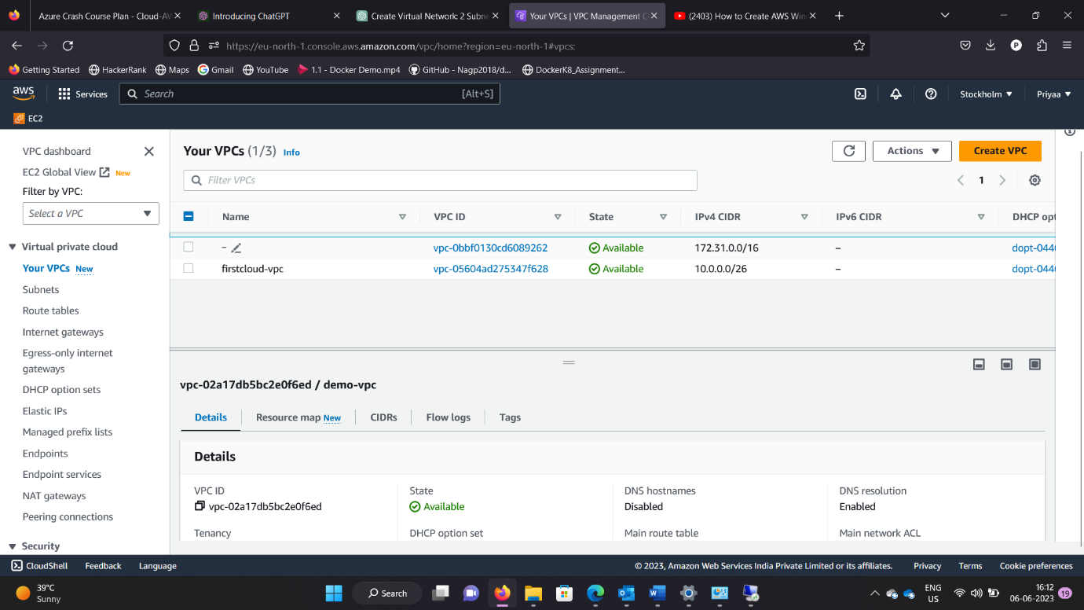

Creating a VM and deploy an application code inside it

Same application to Elastic beanstalk Service

Create a Lambda that should trigger as soon as you upload a file in the S3 bucket,Function should be able to print the name of the file uploaded in the function

